**REAL TIME DROWSINESS DETECTION**

**A PROJECT REPORT**

***Submitted by***

**Arunpandi G (910619205010)**

**Darshan A S (910619205018)**

**Harivarshan T N (910619205020)**

***In Partial fulfilment for the award of the degree***

***Of***

**BACHELOR OF TECHNOLOGY**

**IN**

**INFORMATION TECHOLOGY**



**K.L.N. COLLEGE OF ENGINEERING, POTTAPALAYAM**

**(An Autonomous Institution, Affiliated to Anna university, Chennai)**

**ANNA UNIVERSITY: CHENNAI 600 025**

**JULY 2022**

**ANNA UNIVERSITY: CHENNAI 600 025**

**BONAFIDE CERTIFICATE**

Certified that this project report “**REAL TIME DROWSINESS DETECTION**”

Is the bonafide work of “**G.Arunpandi (Reg No – 910619205010) , A.S.Darshan (Reg No – 910619205018) , T.N.Harivarshan(Reg No – 910619205020)**” who carried out the project work under my supervisor.

SIGNATURE SIGNATURE

Dr. P. Ganesh Kumar, M.E., Ph.D. Dr. S .Ramesh, B.E.(ECE), M.E.(DCNE),MBA,Ph.d.

HEAD OF THE DEPARTMENT ASSOCIATE PROFESSOR

INFORMATION TECHNOLOGY, INFORMATION TECHNOLOGY,

K.L.N. COLLEGE OF ENGINEERING K.L.N. COLLEGE OF ENGINEERING

POTTAPALAYAM, SIVAGANGI, POTTAPALAYAM, SIVAGANGI,

TAMILNADU, INDIA. TAMILNADU,INDIA.

Submitted for the pratical Examination held on __________________

INTERNAL SIGN EXTERNAL SIGN

**ABSTRACT**

* The system of project is aim to number of accidents occur during drivers “drowsiness and fatigue” it will turn to increase driver safety.
* This is common reason for accidents. Some faces and body gestures are consider the sign of drowsiness and fatigue including the tiredness in eyes.
* This problem is indication that driver condition is improper.
* EAR (eye aspect ratio) detect ratio of distance between the horizontal and vertical eye landmarks it is require for detection of drowsiness.
* The proposed system is design to decrease the accidents during driving and the technology to contribute with goal to prevent caused due to road accidents.

**Keywords**—Driver drowsiness; eye detection; blink pattern; fatigue

## **Contents**

|  |  |  |  |
| --- | --- | --- | --- |
| 1 | Introduction | |  |
|  | 1.1 | PURPOSE |  |
|  |  | 1.1.1 HUMAN PSYCHOLOGY |  |
|  |  | 1.1.2 CURRENT STATISTICS |  |
|  | 1.2 | INTENDED AUDIENCE |  |
|  | 1.3 | PRODUCT SCOPE |  |
|  | 1.4 | PROBLEM DEFINITION |  |
|  |  |  |  |
| 2 | Literature Survey | |  |
|  | 2.1 | SYSTEM REVIEW |  |
|  | 2.2 | TECHNOLOGY USED |  |
| 3 | Software Requirements Specification | |  |
|  | 3.1 | PYTHON |  |
|  |  | 3.1.1 LIBRARIES |  |
|  | 3.2 | OPERATING SYSTEM |  |
|  | 3.3 | HARDWARE |  |
| 4 | Requirement Analysis | |  |
|  | 4.1 | PYTHON |  |
|  |  | 4.1.1 LIBRARIES |  |
|  | 4.2 | OPERATING SYSTEM |  |
|  | 4.3 | HARDWARE |  |
|  |  | 4.3.1 LAPTOP |  |
|  |  | 4.3.2 WEBCAM |  |
| 5 | System Design | |  |
|  | 5.1 | USE CASE MODEL |  |
|  | 5.2 | ACTIVITY DIAGRAM |  |
|  | 5.3 | CLASS DIAGRAM |  |
|  | 5.4 | SYSTEM ARCHITECTURE |  |
| 6 | System Testing | |  |
|  | 6.1 | TEST CASES & TEST RESULTS |  |

|  |  |  |  |
| --- | --- | --- | --- |
| 7 | Project Planning | |  |
|  | 7.1 | SYSTEM MODEL |  |
| 8 | Implementation | |  |
| 9 | Screenshots of Project | |  |
|  | 9.1 | NON-DROWSY STATE |  |
|  | 9.2 | DROWSY STATE |  |
| 10 | Conclusion and Future Scope | |  |
|  | 10.1 | CONCLUSION |  |
|  | 10.2 | FUTURE SCOPE. |  |

|  |  |
| --- | --- |
| 11 References |  |

**List of Figures**

|  |  |  |
| --- | --- | --- |
| 5.1 | USE CASE MODEL |  |
| 5.2 | ACTIVITY DIAGRAM |  |
| 5.3 | CLASS DIAGRAM |  |
| 7.1 | BLOCK DIAGRAM |  |

# Chapter 1

## Introduction

#### PURPOSE

* + 1. HUMAN PSYCHOLOGY WITH CURRENT TECHNOLOGY

Humans have always invented machines and devised techniques to ease and protect their lives, for mundane activities like traveling to work, or for more interesting purposes like aircraft travel. With the advancement in technology, modes of transportation kept on advancing and our dependency on it started increasing exponentially. It has greatly affected our lives as we know it. Now, we can travel to places at a pace that even our grandparents wouldn’t have thought possible. In modern times, almost everyone in this world uses some sort of transportation every day. Some people are rich enough to have their own vehicles while others use public transportation. However, there are some rules and codes of conduct for those who drive irrespective of their social status. One of them is staying alert and active while driving.

Neglecting our duties towards safer travel has enabled hundreds of thousands of tragedies to get associated with this wonderful invention every year. It may seem like a trivial thing to most folks but following rules and regulations on the road is of utmost importance. While on road, an automobile wields the most power and in irresponsible hands, it can be destructive and sometimes, that carelessness can harm lives even of the people on the road. One kind of carelessness is not admitting when we are too tired to drive. In order to monitor and prevent a destructive outcome from such negligence, many researchers have written research papers on driver drowsiness detection systems. But at times, some of the points and observations made by the system are not accurate enough. Hence, to provide data and another perspective on the problem at hand, in order to improve their implementations and to further optimize the solution, this project has been done.

* + 1. FACTS & STATISTICS

Our current statistics reveal that just in 2015 in India alone, 148,707 people died due to car related accidents. Of these, at least 21 percent were caused due to fatigue causing drivers to make mistakes. This can be a relatively smaller number still, as among the multiple causes that can lead to an accident, the involvement of fatigue as a cause is generally grossly underestimated. Fatigue combined with bad infrastructure in developing countries like India is a recipe for disaster. Fatigue, in general is very difficult to measure or observe unlike alcohol and drugs, which have clear key indicators and tests that are available easily. Probably, the best solutions to this problem are awareness about fatigue-related accidents and promoting drivers to admit fatigue when needed. The former is hard and much more expensive to achieve, and the latter is not possible without the former as driving for long hours is very lucrative. When there is an increased need for a job, the wages associated with it increases leading to more and more people adopting it. Such is the case for driving transport vehicles at night. Money motivates drivers to make unwise decisions like driving all night even with fatigue. This is mainly because the drivers are not themselves aware of the huge risk associated with driving when fatigued. Some countries have imposed restrictions on the number of hours a driver can drive at a stretch, but it is still not enough to solve this problem as its implementation is very difficult and costly.

#### INTENDED AUDIENCE

The intended audience for this document are the development team, the project evaluation jury, and other tech-savvy enthusiasts who wish to further work on the project.

#### PRODUCT SCOPE

There are many products out there that provide the measure of fatigue level in the drivers which are implemented in many vehicles. The driver drowsiness detection system provides the similar functionality but with better results and additional benefits. Also, it alerts the user on reaching a certain saturation point of the drowsiness measure.

#### PROBLEM DEFINITION

Fatigue is a safety problem that has not yet been deeply tackled by any country in the world mainly because of its nature. Fatigue, in general, is very difficult to measure or observe unlike alcohol and drugs which have clear key indicators and tests that are available easily. Probably, the best solutions to this problem are awareness about fatigue-related accidents and promoting drivers to admit fatigue when needed. The former is hard and much more expensive to achieve, and the latter is not possible without the former as

driving for long hours is very lucrative.

# Chapter 2

## Literature Survey

#### SYSTEM REVIEW

This survey is done to comprehend the need and prerequisite of the general population, and to do as such, we went through different sites and applications and looked for the fundamental data. Based on these data, we made an audit that helped us get new thoughts and make different arrangements for our task. We reached the decision that there is a need of such application and felt that there is a decent extent of progress in this field too.

#### TECHNOLOGY USED

1. PYTHON - Python is an interpreted, high-level, general-purpose programming language. Python's design philosophy emphasizes code readability with its notable use of significant whitespace. Its language constructs and object-oriented approach aim to help programmers write clear, logical code for small and large-scale projects. Python is dynamically typed AND supports multiple programming paradigms, including procedural, object-oriented, and functional programming.
2. JUPYTER Lab - Project Jupyter is a [nonprofit organization](https://en.wikipedia.org/wiki/Nonprofit_organization) created to develop [open-source software](https://en.wikipedia.org/wiki/Open-source_software), open-standards, and services for [interactive computing](https://en.wikipedia.org/wiki/Interactive_computing) across dozens of programming languages.
3. IMAGE PROCESSING - In [computer science](https://en.wikipedia.org/wiki/Computer_science), digital image processing is the use of computer [algorithms](https://en.wikipedia.org/wiki/Algorithm) to perform image processing on [digital](https://en.wikipedia.org/wiki/Digital_image) [images](https://en.wikipedia.org/wiki/Digital_image).
4. MACHINE LEARNING - Machine learning is the [scientific](https://en.wikipedia.org/wiki/Branches_of_science) [study](https://en.wikipedia.org/wiki/Branches_of_science) of [algorithms](https://en.wikipedia.org/wiki/Algorithm) and [statistical models](https://en.wikipedia.org/wiki/Statistical_model) that [computer systems](https://en.wikipedia.org/wiki/Computer_systems) use in order to perform a specific task effectively without using explicit instructions, relying on patterns and inference instead. It is seen as a subset of [artificial intelligence](https://en.wikipedia.org/wiki/Artificial_intelligence). Machine learning algorithms build a [mathematical model](https://en.wikipedia.org/wiki/Mathematical_model) based on sample data, known as "[training data](https://en.wikipedia.org/wiki/Training_data)", in order to make predictions or decisions without being explicitly told.

# Chapter 3

## Software Requirements Specification

#### Python:

* Python 3

#### Libraries

* Numpy
* Scipy
* Playsound
* Dlib
* Imutils
* opencv, etc.

#### Operating System

* Windows or Ubuntu

## Hardware Requirements Specification

* + 1. Laptop with basic hardware.
    2. Webcam

**Chapter 4**

Requirement Analysis

* 1. Python: Python is the basis of the program that we wrote. It utilizes many of the python libraries.
  2. Libraries:
* Numpy: Pre-requisite for Dlib
* Scipy: Used for calculating Euclidean distance between the eyelids.
* Playsound: Used for sounding the alarm
* Dlib: This program is used to find the frontal human face and estimate its pose using 68 face landmarks.
* Imutils: Convenient functions written for Opencv.
* Opencv: Used to get the video stream from the webcam, etc.
  1. OS: Program is tested on Windows 10 build 1903 and PopOS 19.04
  2. Laptop: Used to run our code.
  3. Webcam: Used to get the video feed

**Chapter 5**

## System Design

#### USE CASE DIAGRAM

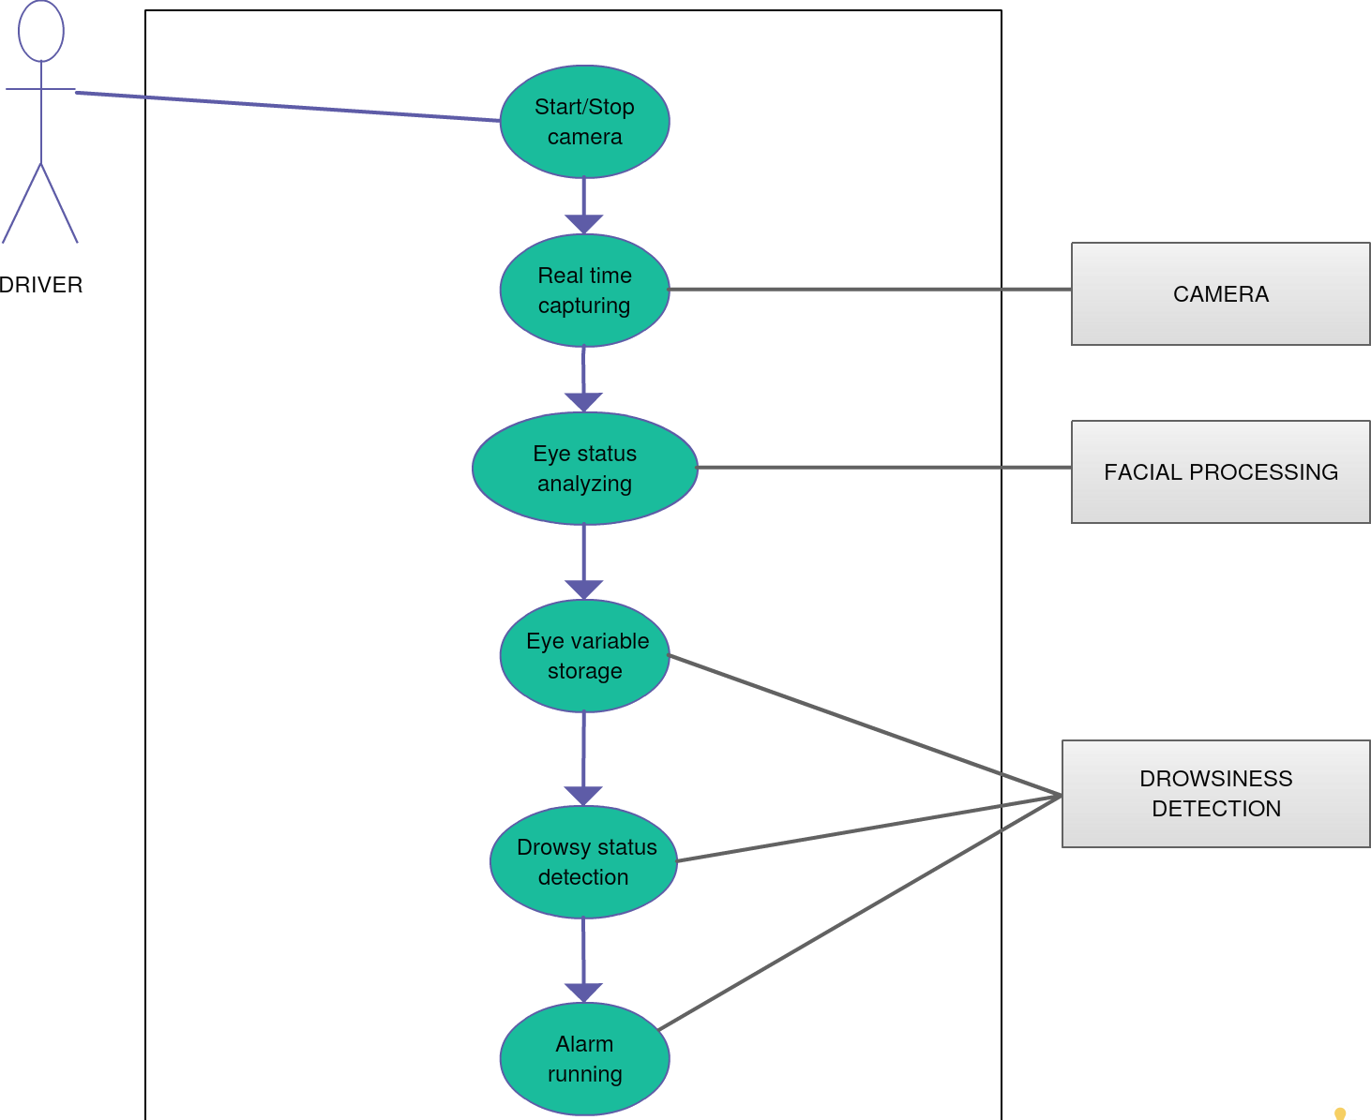

FIGURE 1

#### ACTIVITY DIAGRAM

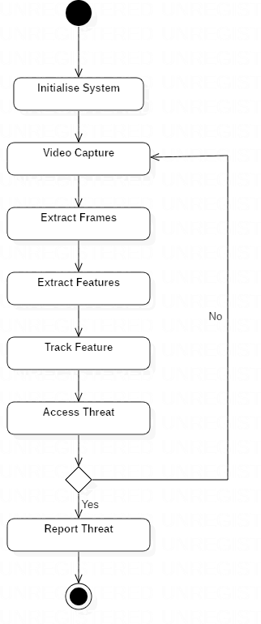

FIGURE 2

#### CLASS DIAGRAM

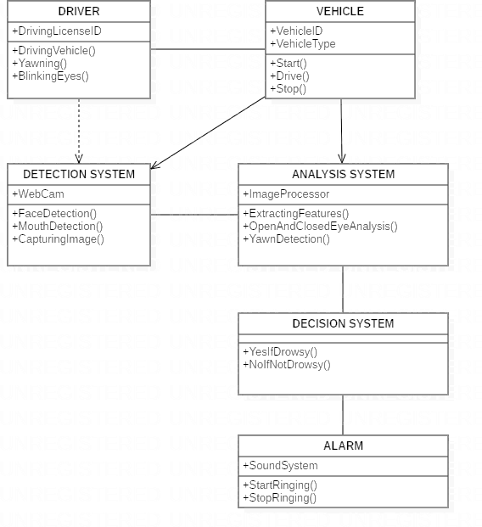

FIGURE 3

5.4 SYSTEM ARCHITECTURE

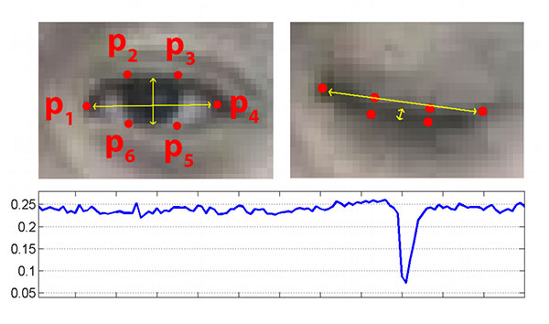

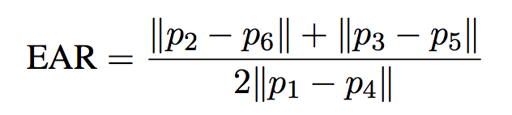

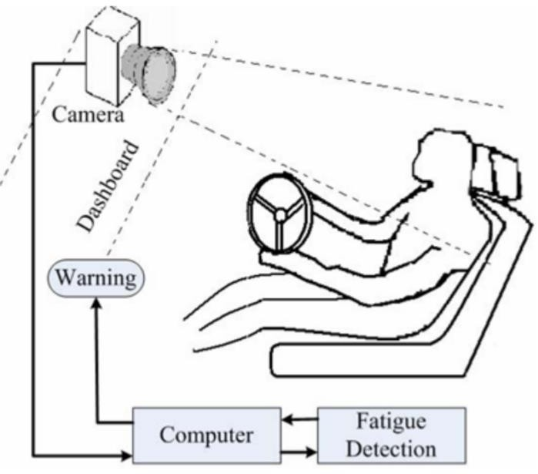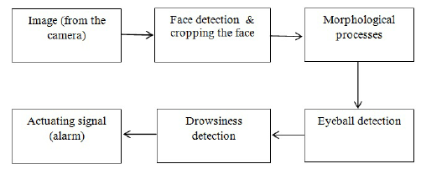

# Chapter 6

## System Testing

6.1 Test Cases and Test Results

|  |  |  |  |  |
| --- | --- | --- | --- | --- |
| Test | Test Case Title | Test Condition | System Behavior | Expected Result |
| ID |
| T01 | NSGY | Straight Face, Good Light, With Glasses | Non Drowsy | Non Drowsy |
| T02 | YTGN | Tilted Face, Good Light, No Glasses | Drowsy | Drowsy |
| T03 | YTGY | Tilted Face, Good Light, With Glasses | Drowsy | Drowsy |

Note: Testing is performed manually

# TEST RESULT:

# 

# Non Drowsy

# 

# 

1. Drowsy

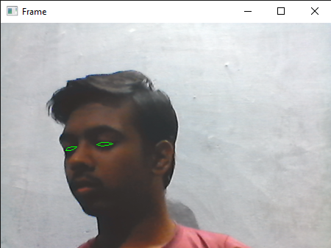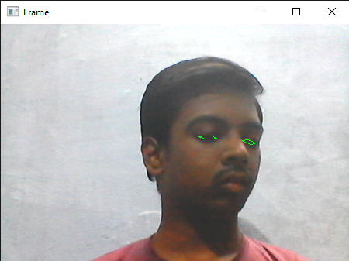

**Chapter 7**

## Project Planning

* 1. SYSTEM MODEL

The framework is created utilizing the incremental model. The center model of the framework is first created and afterwards augmented in this way in the wake of testing at each turn. The underlying undertaking skeleton was refined into expanding levels of ability.

At the following incremental level, it might incorporate new execution backing and improvement.

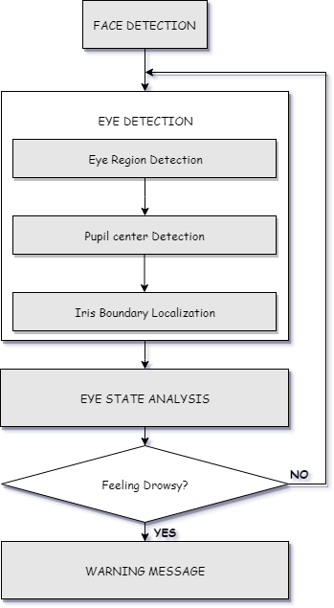

Figure 4: Block diagram

# Chapter 8

## Implementation

* + - 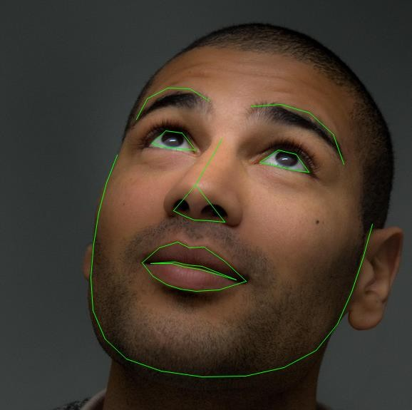In our program we used Dlib, a pre-trained program trained on the HELEN dataset to detect human faces using the pre-defined 68 landmarks.

Landmarked Image of a person by Dlib

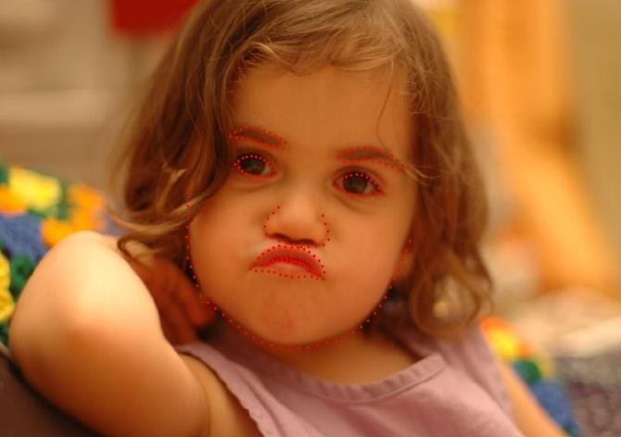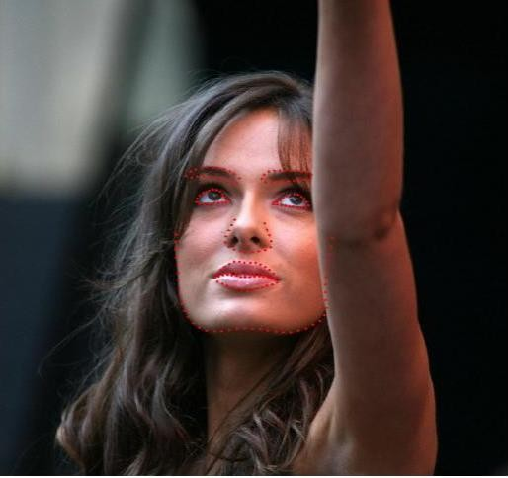

HELEN Dataset Samples

* + - After passing our video feed to the dlib frame by frame, we are able to detect left eye and right eye features of the face.
    - Now, we drew contours around it using OpenCV.
    - Using Scipy’s Euclidean function, we calculated sum of both eyes’ aspect ratio which is the sum of 2 distinct vertical distances between the eyelids divided by its horizontal distance.

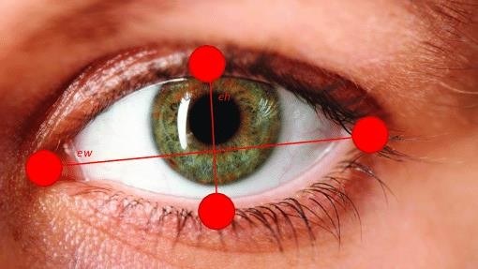

Eyes with horizontal and vertical distance marked for Eye Aspect Ratio calculation.

* + - Now we check if the aspect ratio value is less than 0.25 (0.25 was chosen as a base case after some tests). If it is less an alarm is sounded and user is warned.

# Chapter 9

## Screenshots of Project

#### Non-drowsy Person:

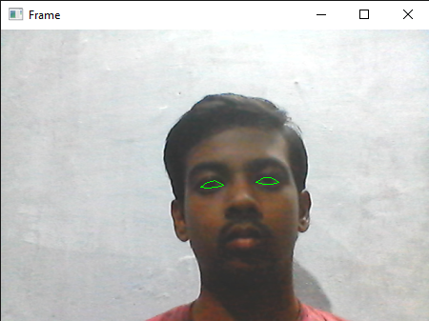

Non-drowsy state

#### Drowsy Person:



Different aspect ratio at drowsy state

# Chapter 10

## Conclusion and Future Scope

* 1. Conclusion

It completely meets the objectives and requirements of the system. The framework has achieved an unfaltering state where all the bugs have been disposed of. The framework cognizant clients who are familiar with the framework and comprehend it's focal points and the fact that it takes care of the issue of stressing out for individuals having fatigue-related issues to inform them about the drowsiness level while driving.

* 1. Future Scope

The model can be improved incrementally by using other parameters like blink rate, yawning, state of the car, etc. If all these parameters are used it can improve the accuracy by a lot.

We plan to further work on the project by adding a sensor to track the heart rate in order to prevent accidents caused due to sudden heart attacks to drivers.

Same model and techniques can be used for various other uses like Netflix and other streaming services can detect when the user is asleep and stop the video accordingly. It can also be used in application that prevents user from sleeping.

## References

* + 1. COMPUTATIONALLY EFFICIENT FACE DETECTION; B. SCHLKOPF-A. BLAKE, S. ROMDHANI, AND P. TORR.
    2. USE OF THE HOUGH TRANSFORMATION TO DETECT LINES AND CURVES IN PICTURE; R. DUDA AND P. E. HART.
    3. JAIN, “FACE DETECTION IN COLOR IMAGES; R. L. HSU, M. ABDEL- MOTTALEB, AND A. K. JAIN.
    4. OPEN/CLOSED EYE ANALYSIS FOR DROWSINESS DETECTION;

P.R. TABRIZI AND R. A. ZOROOFI.

* + 1. <http://ncrb.gov.in/StatPublications/ADSI/ADSI2015/chapter1A%20traffic>

%20accidents.pdf

[6] http://www.jotr.in/text.asp?2013/6/1/1/118718

[7] <http://dlib.net/face_landmark_detection_ex.cpp.html>